Hi Hans,
I hope this letter finds you well! I heard that you are currently studying oceanography at the Ocean University of China, and I want to share with you some great facts that I learned in my atmospheric class at the University of Washington, Seattle.
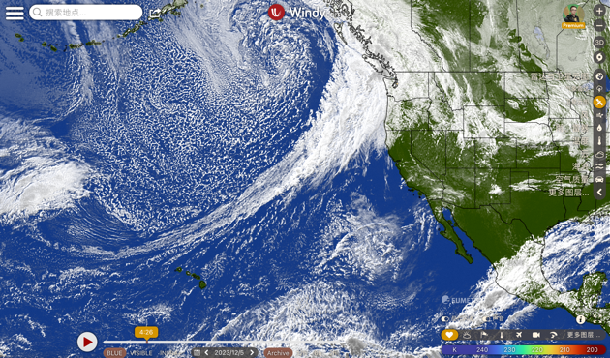
Since our major is highly related, you must hear about something called the atmospheric river on the Pacific Ocean. From mid-December 2022 to mid-January 2023, California experienced a huge flood due to consecutive days of heavy rain, causing widespread traffic disruptions and power outages, and twenty-six million people were under flood alert. All these natural disasters were caused by the strong atmospheric river, a special natural phenomenon that can transport water from thousands of kilometers away. The concept of an atmospheric river was first proposed by Yong Zhu and Reginald E. Newell in 1994, and they found that there is a long and thin ribbon structure in the atmosphere, and its water-carrying capacity can be compared to the Amazon River. That's incredible! Can you imagine a river with the highest discharge in the world flowing over your head? And this sky river made the city where I live, Seattle, rain for about a week! I had to carry an umbrella all the time that week, and the hilly street turned into a river.
Figure 1 Satellite cloud picture of atmospheric river on 5 Dec. 2023
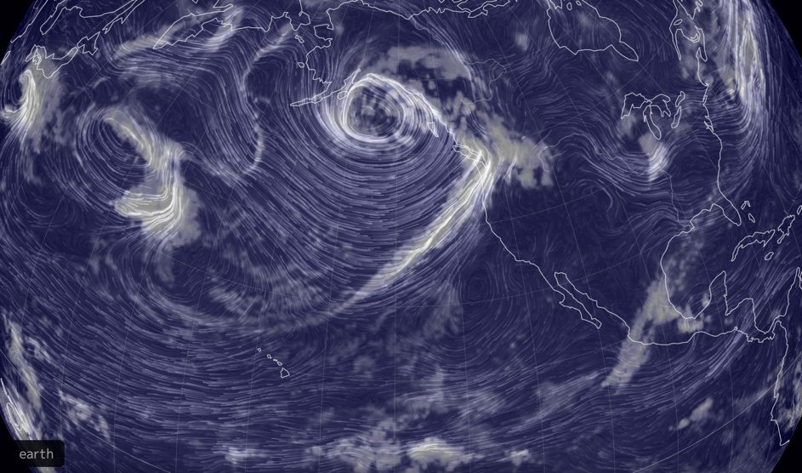
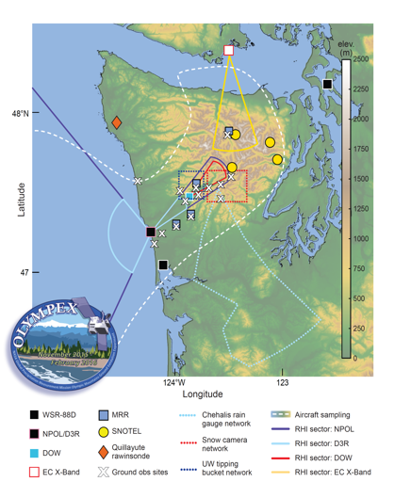
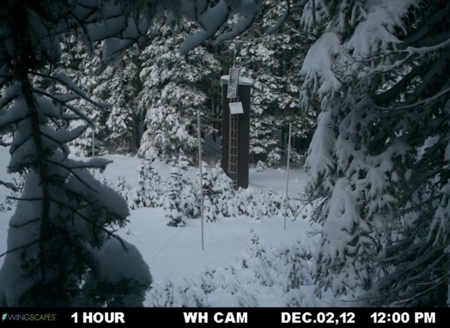
According to NOAA, about 30 to 50 percent of the annual precipitation on the West Coast of the United States is caused by atmospheric river events. The atmospheric river delivers a huge amount of moisture from Hawaii all the way to the west coast of the United States, causing heavy rains on the west side of the Cascades and Rocky Mountains. Since the Hawaiian area produces pineapples, this atmospheric river has a funny name: Pineapple Express. Once people realized the importance of atmospheric rivers, NOAA began researching and predicting them. Ralph and his team of researchers working for NOAA flew into the atmospheric river in 1998 to collect important data. The atmospheric river caused the Olympic Mountain areas on the west of Seattle city to receive heavy snowfall. I learned in class that meteorologists in the OLYMPEX program set up meteorological observation stations on Olympic Mountain to track the huge precipitation amount and compare it with the satellite data. Prof. McMurdie said, “Sometimes the snow is so deep that it covers the instruments, so we used a long stick called the snowpole and worked with cameras to measure the snow depth.”
Figure 2 Cloud moisture on 850hPa of atmospheric river on 5 Dec. 2023
Figure 3 The OLYMPEX program from Prof. McMurdie PPT slides
Figure 4 Snowpole from Prof. McMurdie PPT slides
The atmospheric river also occurred in China and worked with the subtropical high and the southern trough to cause heavy rains in the middle and lower reaches of the Yangtze River. For example, Zhengzhou experienced a heavy rainfall on July 20, 2021. According to the China Meteorological Administration, the amount of precipitation from 4 p.m. to 5 p.m. on that day was 201.9 mm, causing 292 deaths. As you study the ocean, I encourage you to do more research on atmospheric rivers and find out the cause and effect of ocean currents, evaporation, and precipitation. Perhaps we can work together to understand more about the atmospheric river and help predict and prevent natural disasters in the future.

Best,
Leo Luo

